Course Registration Management System

Important Instructions:
Please read the instructions carefully before doing the questions.
- You are NOT allowed to use any other materials. You are NOT allowed to use any device to share data with others.
- You must use Visual Studio 2019 or above, MSSQL Server 2008 or above for your development tools.

IMPORTANT - before you start doing your solution, MUST DO the following steps:
- Create a Solution in Visual Studio named PE_PRN222_FA25_00000000_StudentName. Inside your Solution, the Project ASP.NET Core Razor Page must be named: CourseRegistrationManagement_StudentName.
- To create your program, you must use ASP.NET Core Web App (Razor Pages), apply a 3-Layer architecture (Presentation Layer, Business Logic Layer, Data Access Layer), and there must be at least 2 Projects for the Solution. The database connection string must be retrieved from the appsettings.json file.
In the case your code connects directly to the database from ASP.NET Core Web App (Razor Pages) or hardcodes the connection string, you will get 0 points.
- Create your MS SQL database named FA25CourseRegistrationDB by running the code in the script FA25CourseRegistrationDB.sql.
- Set the default user interface for your project as a Login page.
- If there are syntax errors or compilation errors in your PE program, you will not pass the PE requirements, and the mark will be 0.
- Your work will be considered invalid (0 points) if your code inserts stuff that is unrelated to the test.

Create an application using ASP.NET Core Razor Pages with .NET Core (.NET 5/.NET 6/.NET 7/.NET 8), C#, and ADO.NET (or Entity Framework Core). An MS SQL Server database will be created to persist the data and it will be used for reading and managing data.

Database Structure:
Table Name | Key Fields | Description
Registration | RegistrationID, RegistrationTitle, CourseType, RegistrationDate, StartDate, InstructorID, Fee, Status | Main transaction entity for course registration
Instructor | InstructorID, FullName, Email, Phone, Department, Specialization | Instructor information entity
SystemUser | UserID, UserPassword, Username, UserRole, RegistrationDate, Email | Authentication entity

System User Roles (SystemUser.UserRole):
- Administrator = 1
- Manager = 2
- Staff = 3
- Member = 4
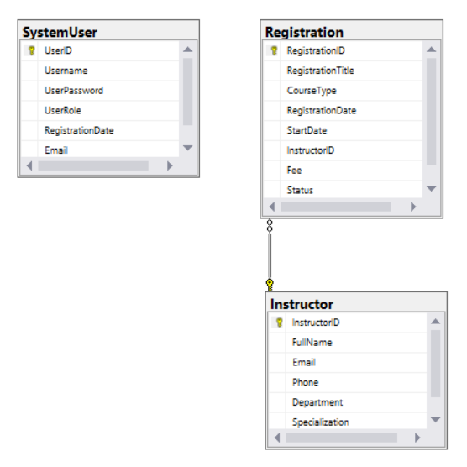

Functional Requirements:

1. (1.0 point) Authentication function
Use Username and UserPassword from the SystemUser table for the authentication/authorization process.
- All CRUD and search actions are required for the Manager role.
- The Staff role is required for Search and Read actions only.

2. (2.0 points) List Registration Records
Check if login is successful (either Staff or Manager role), list all registration items from the Registration table (each record includes information from Registration and the FullName of the associated Instructor).
Paging is required for this function, with 3 records per page.

3. (1.0 point) Delete Registration
If a user with a Manager role logs in successfully, delete the selected registration item with confirmation, then update the list of registration items.

4. (2.5 points) Add New Registration
If a user with a Manager role logs in successfully, add a new registration item with the following requirements:
- The new registration item will display at the top of the list.
- All fields of Registration are required.
Validation Rules:
- RegistrationTitle: Must be between 10 and 100 characters long. Special characters like @, #, $, % are not allowed.
- CourseType: Must be one of the predefined values: "Technical", "Business", "Language", "Design", "Marketing".
- RegistrationDate: Cannot be a future date. Must be in a valid date format (YYYY-MM-DD).
- StartDate: Must be after the RegistrationDate. Must be in a valid date format (YYYY-MM-DD).
- Fee: Must be a positive number and greater than 1000 (VND).
- The InstructorID/FullName will come from the Instructor table (you can use a ComboBox/Select UI control in this case).

5. (2.0 points) Update Registration
If a user with a Manager role logs in successfully, update the selected existing registration item.
- For the update function, the same validation requirements as the Add function apply.
- All fields should be pre-populated with current data.

6. (1.5 points) Search Registration
If a user with a Manager role logs in successfully, search all registration items with 3 conditions: RegistrationTitle, CourseType, RegistrationDate.
Search Requirements:
- An OR option should be available for this case
- Relative search should be used (partial matching for RegistrationTitle)
- Search results need to be grouped by RegistrationTitle, CourseType, RegistrationDate
- Maintain pagination for search results (3 records per page)

